[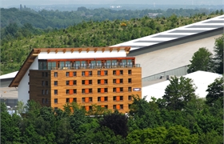](https://www.snowworld.com/nl/Hotel/Hotel-SnowWorld/Contact-Route)